Interim Project

Soham Chakraborty EmployeeID: 2276590

**Project Topic :-**

Optimize Hive Performance by partitioning and bucketing tables

**Requirements :-**

**1.Project datasets -**

**a.OnlineRetail.csv**

**Columns -**

● **invoice_no:** This column stores the unique identifier for each invoice or transaction.

● **stock_code:** This column stores the stock code or identifier for each item sold in the transaction.

● **item:** This column stores the name or description of the item sold in the transaction.

● **quantity:** This column stores the quantity of the item sold in the transaction.

● **invoice_date:** This column stores the date of the invoice or transaction.

● **unit_price:** This column stores the unit price of the item sold in the transaction.

● **customer_id:** This column stores the unique identifier for each customer.

● **country:** This column stores the country associated with the transaction.

**b.Customer.csv**

**Columns -**

* **Customer_id:** This colum stores the unique identifier for each customer
* **name :** This column stores the name of the customer
* **email:** This column stores the email of the customer
* **phone_no:** This column stores the phone number of the customer

**2.Technology used :-**

● Hadoop Ecosystem

● Hive - Data warehouse infrastructure built on top of Hadoop for querying and analyzing large datasets.

● HDFS - Distributed file system for storing large datasets.

**Introduction and Description:-**

**Hive and why we need it in Hadoop :-**

● **SQL Interface to Hadoop:** HiveQL provides a familiar SQL-like interface to interact with Hadoop data, making it accessible to users who are already familiar with SQL. This lowers the barrier to entry for data analysts and SQL developers who want to leverage Hadoop's capabilities without learning new programming paradigms.

● **Scalability:** Hive is designed to handle large-scale datasets stored in Hadoop's distributed file system. It leverages the distributed processing power of Hadoop to execute queries in parallel across multiple nodes, enabling scalable data processing for big data analytics.

● **Optimized for Batch Processing:** Hive is optimized for batch processing of large volumes of data. It is well-suited for running complex analytical queries, data transformations, and ETL (Extract, Transform, Load) operations on structured and semi-structured data stored in Hadoop.

● **Integration with Hadoop Ecosystem:** Hive seamlessly integrates with other components of the Hadoop ecosystem, such as HDFS, Apache HBase, Apache Spark, Apache Tez, and Apache YARN. This allows users to leverage the capabilities of these tools for various data processing tasks while using Hive as the query interface.

**How do we optimize Hive performance by using Partitioning and Bucketing :-**

**Partitioning:**

Partitioning involves dividing data into multiple partitions based on the values of one or more columns. This helps in reducing the amount of data that needs to be scanned during query execution.

**Benefits of Partitioning:**

● **Data Pruning:** Queries only need to process data within specific partitions, reducing the amount of data scanned.

● **Parallel Processing:** Partitioned data can be processed in parallel across multiple nodes, improving query performance.

**Bucketing:**

Bucketing involves grouping data into a fixed number of buckets based on the hash value of a column. This helps in evenly distributing data and improving query performance for certain types of queries, especially joins and aggregations.

**Benefits of Bucketing:**

● **Data Locality:** Data within each bucket is stored together, improving locality for joins and aggregations.

● **Sampling:** Bucketing can be used for data sampling and approximate query processing.

**Optimizing Hive Performance Using Partitioning and Bucketing:-**

● **Partitioning and Bucketing Together:** Use both partitioning and bucketing for optimal performance. Partition data by frequently used filtering columns and bucket data within each partition based on join or aggregation keys.

● **Choose Appropriate Columns:** Select partitioning and bucketing columns based on query patterns and access patterns. Consider columns used in filtering, joining, and aggregating data.

● **Monitor and Tune:** Regularly monitor query performance and adjust partitioning and bucketing strategies based on changing data and query patterns.

**Steps of the project :-**

**1.Data Ingestion:Import the Online Retail data from the local system into HDFS.**

After opening the shell I am changing the directory to locate to the HADOOP HOME folder and sbin . After that I am starting all the hadoop daemons and checking whether they are working properly .

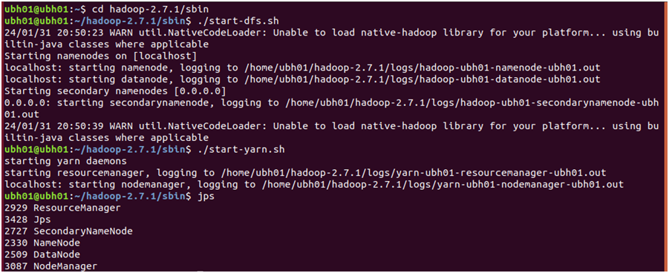

After that I have made a folder in the hadoop HDFS called ecommercedata with a specified custom path and then uploading OnlineRetail dataset from the local system to the HDFS folder

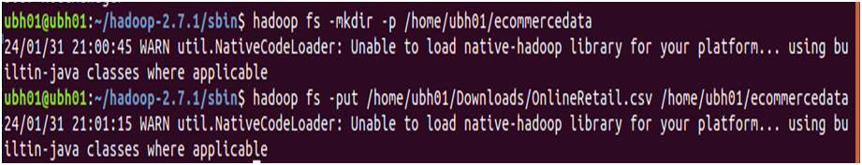

**2. Creating a hive table and storing the data from the HDFS to the hive table**

I have created a hive table using the same column types . Eventually I am importing the dataset from the HDFS to the hive table

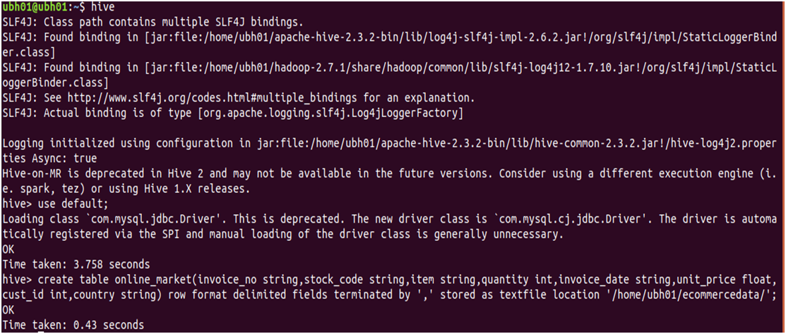

After that I am using HiveQL for displaying the data in order to check whether the data has been imported successfully into the table or not . HiveQL is similar to SQL (Structured Query Language) and provides a familiar syntax for users who are already familiar with SQL.HiveQL allows users to perform various operations such as creating, altering, and dropping tables, as well as querying and manipulating data using SQL-like syntax.

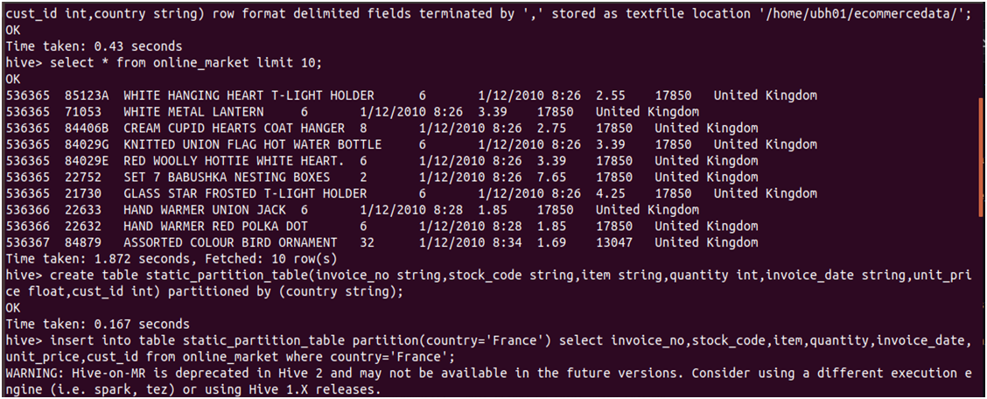

**3. Partitioning of table to enable efficient data retrieval and management:**

**Static partition table** :-

First we will create a static partition table partitioned by the column country . A static partition table in Hive is a type of table where the partitions and their corresponding directories in HDFS are predefined and fixed. In other words, the partition values are explicitly specified when the table is created, and they do not change over time. After that we will manually make a partition in the table for the country France and insert values into it . Similarly we will be following the exact steps to create the partitions of Australia and Netherlands . So , we would have created 3 partitions .



Partition will allow data to be organized into separate directories in HDFS based on the values of the column country.

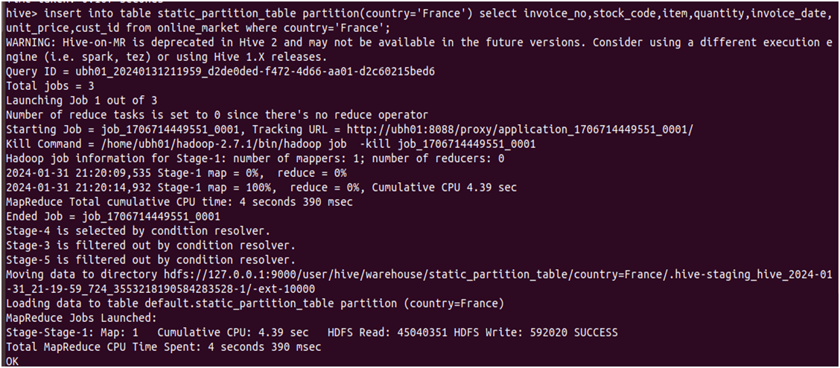

After that if we check in the web browser in localhost:50070 for hadoop we will find the partitions as shown

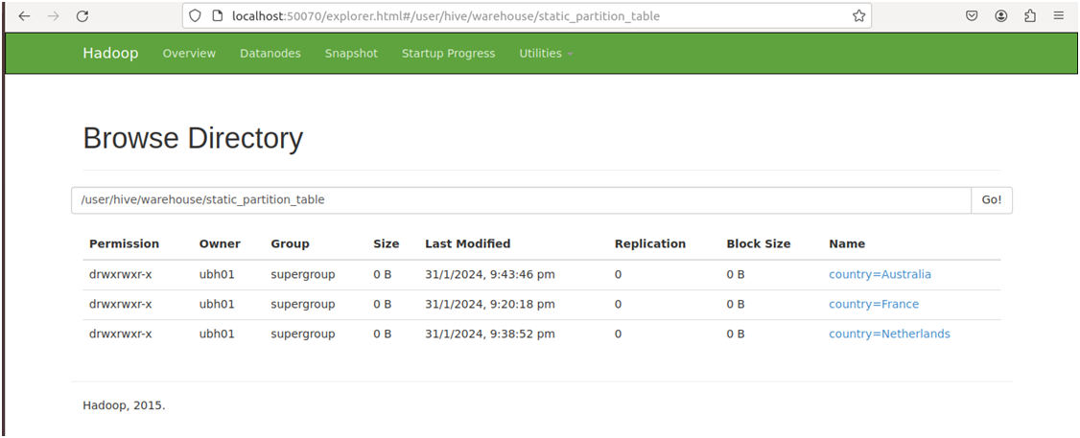

In the shell also we can check for the same using hadoop fs -ls command and the required path

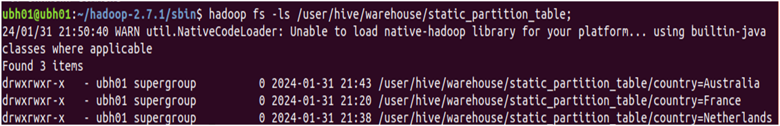

**Dynamic Partitioning :**

We can use dynamic partitioning only if we set dynamic partitioning mode as nonstrict

Dynamic partitioning in Hive refers to the process of automatically determining and creating partitions based on the values of one or more columns in the dataset being inserted into a table. Unlike static partitioning, where partition values are predefined and fixed, dynamic partitioning allows Hive to dynamically generate partitions based on the data being ingested.

So we can create the dynamic partition table and insert data into the table by partitioning using the column country . We will be getting all the partitions dynamically made by hive . So , for 38 countries we will get 38 partitions .

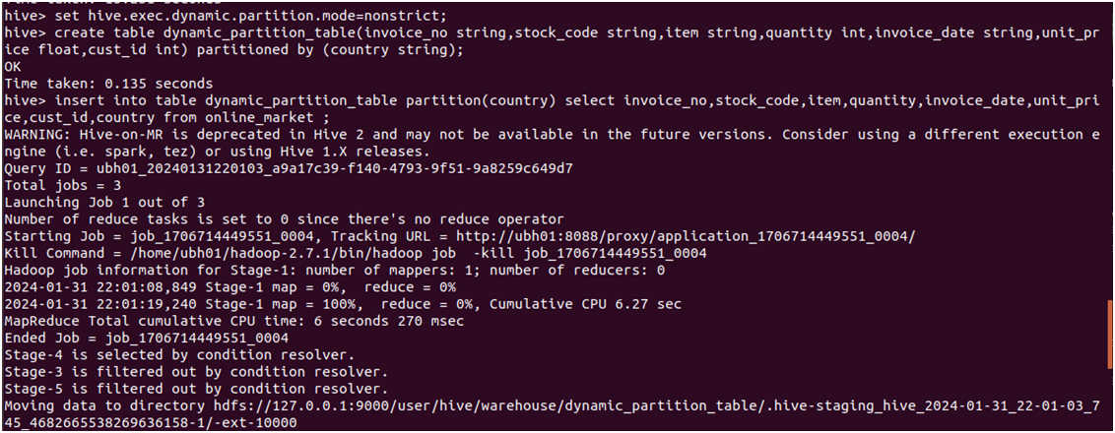

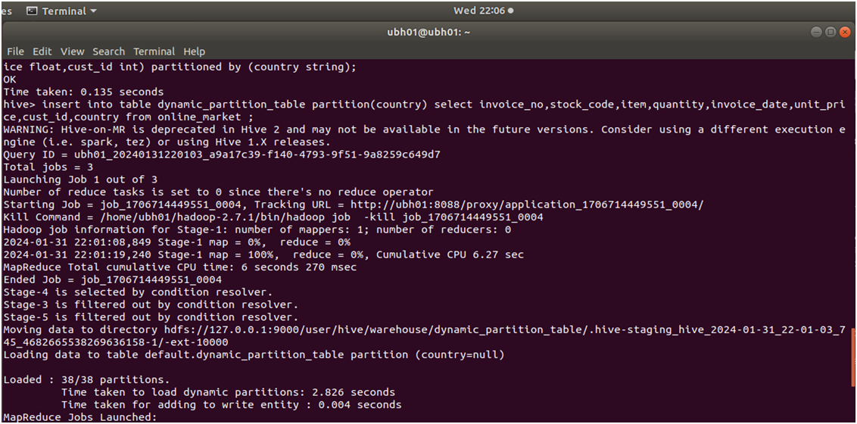

If we query the data then we will see that the data from a single partition is getting displayed together alphabetically

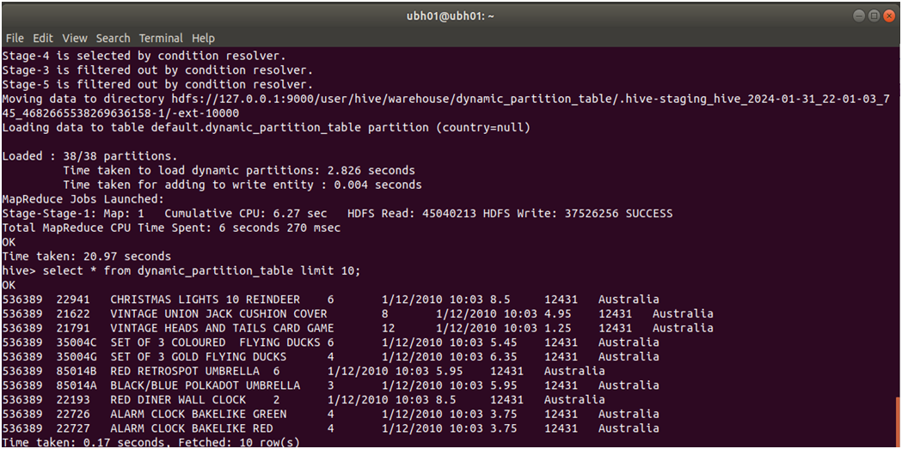

Like static partition , here also we can check for the number of partitions by using hadoop fs -ls command and the required path

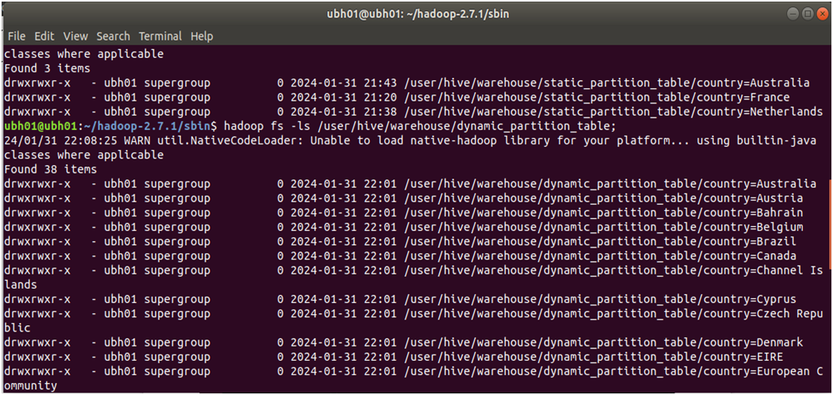

In the web browser visualization of the file structure of hadoop we can find the partitions as listed below :

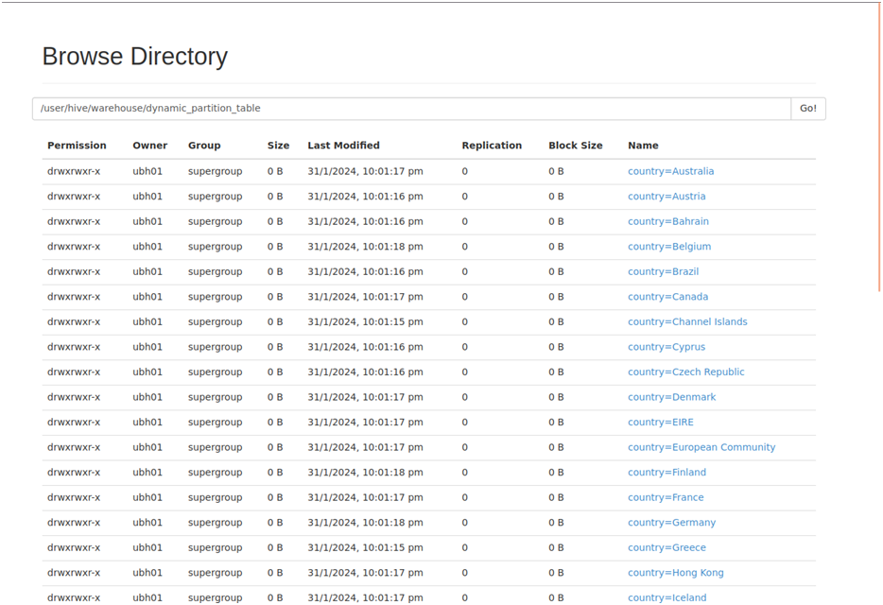

Now we will compare the performance of a partitioned table with a non partitioned table by running the same query and running a shell script to calculate the execution time

The screenshot of the shell script to find the execution time of the given query is displayed below

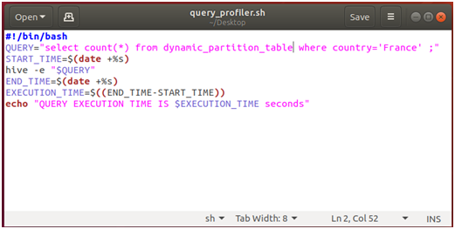

If we run this script on the partitioned table then we can see that the command got executed in 14s

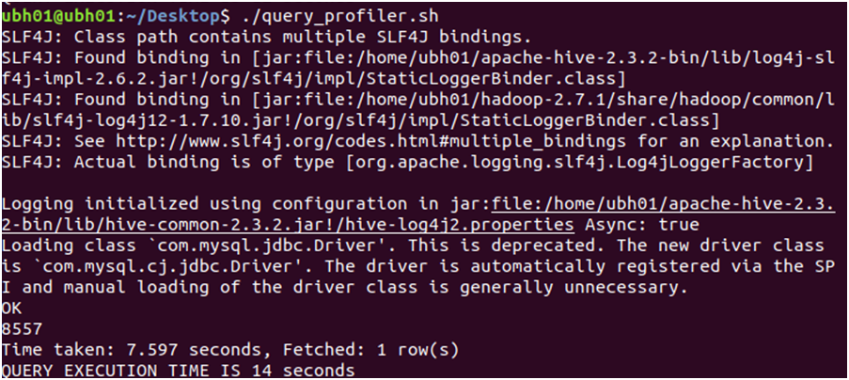

On running the same shell script to calculate the execution time on a non partitioned table with the same query , the execution time is coming as 33s which clearly indicated that partitioning has greatly improved query performance

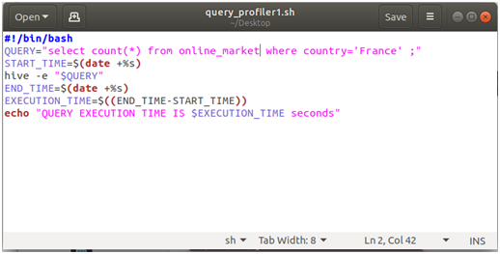

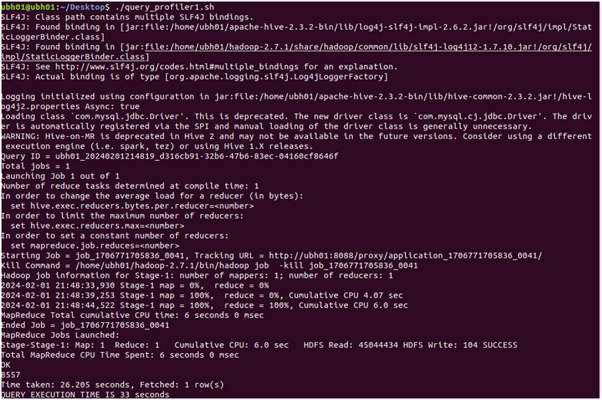

Partitioning saves time by organizing data into separate segments based on predefined criteria,country in this case , which allows the query engine to skip scanning irrelevant partitions, process partitions concurrently for parallel processing, eliminate unnecessary partitions through partition pruning, and skip over irrelevant data blocks within partitions using data skipping techniques, all of which collectively optimize data retrieval and processing, leading to faster query execution times.

**Data Analysis using the Partitioned Table :**

**1.Query the total sales revenue by country :**

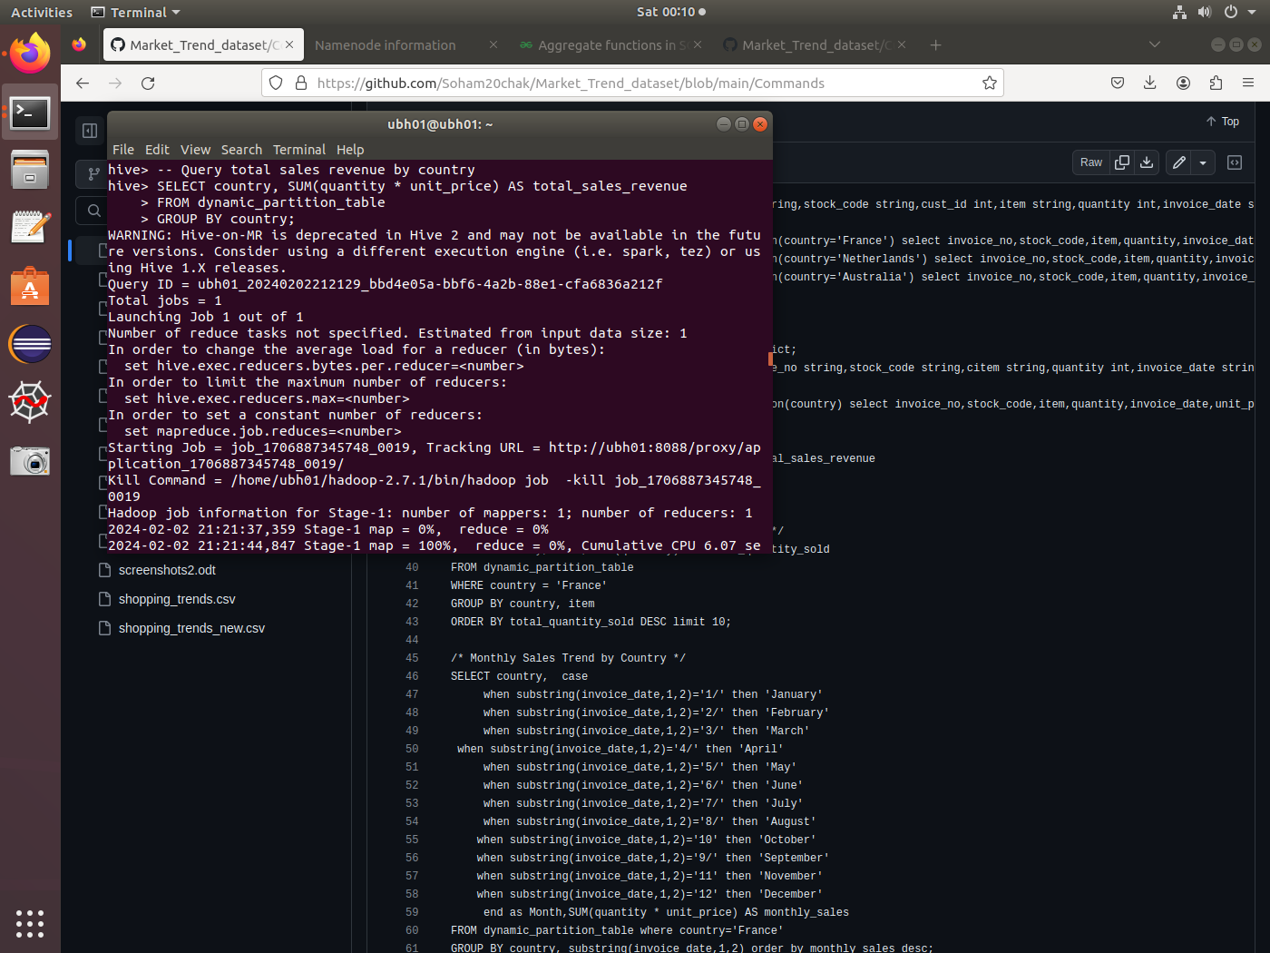

**Result :**

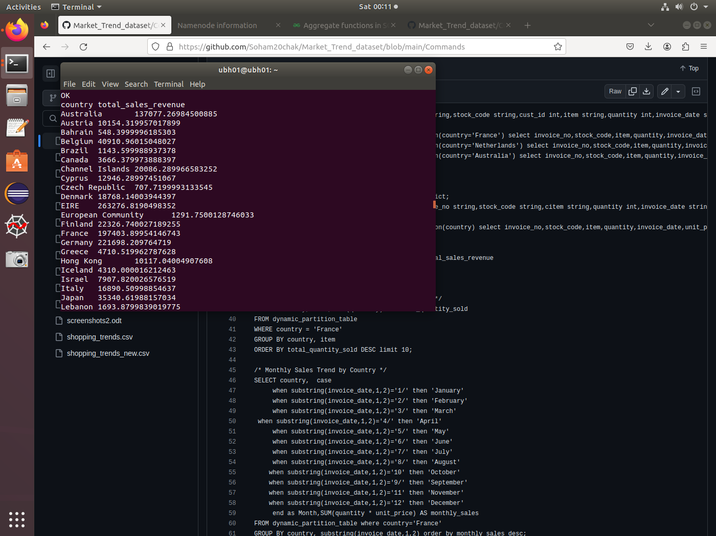

**2.Query top selling items in a specific country:**

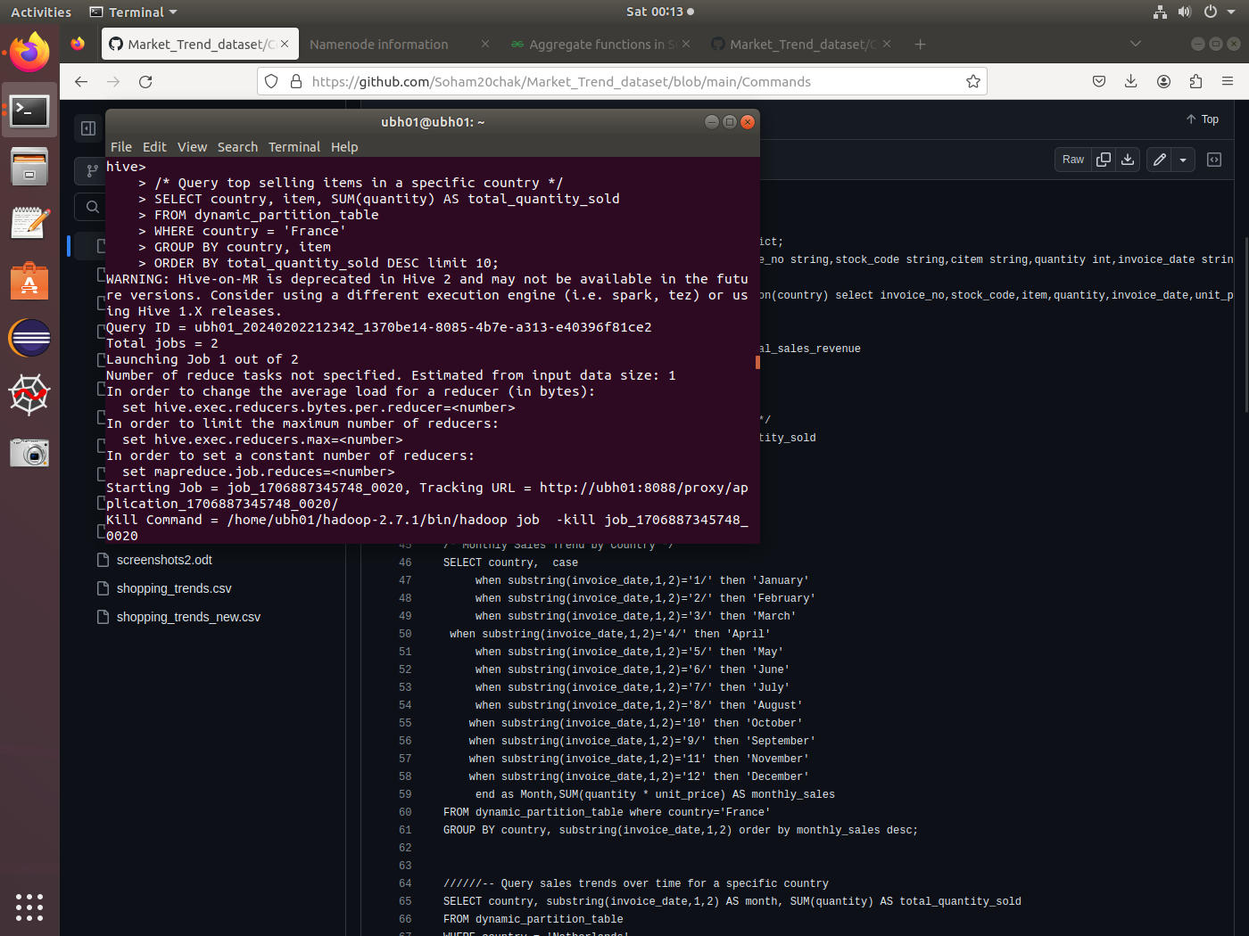

**Result:**

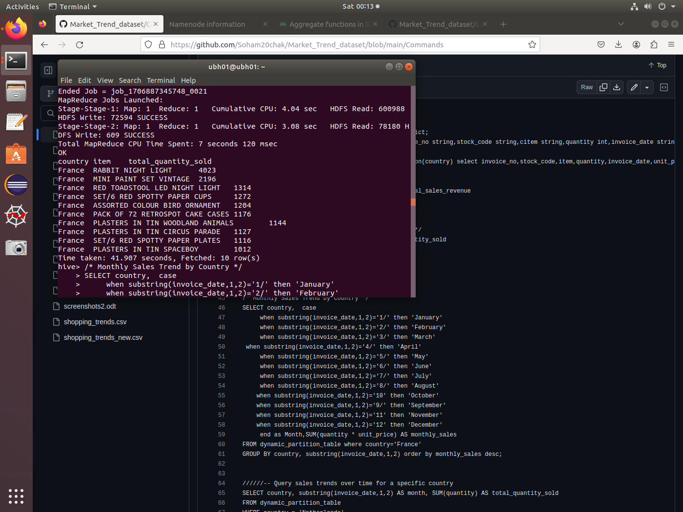

**3.Monthly Sales Trend by Country:**

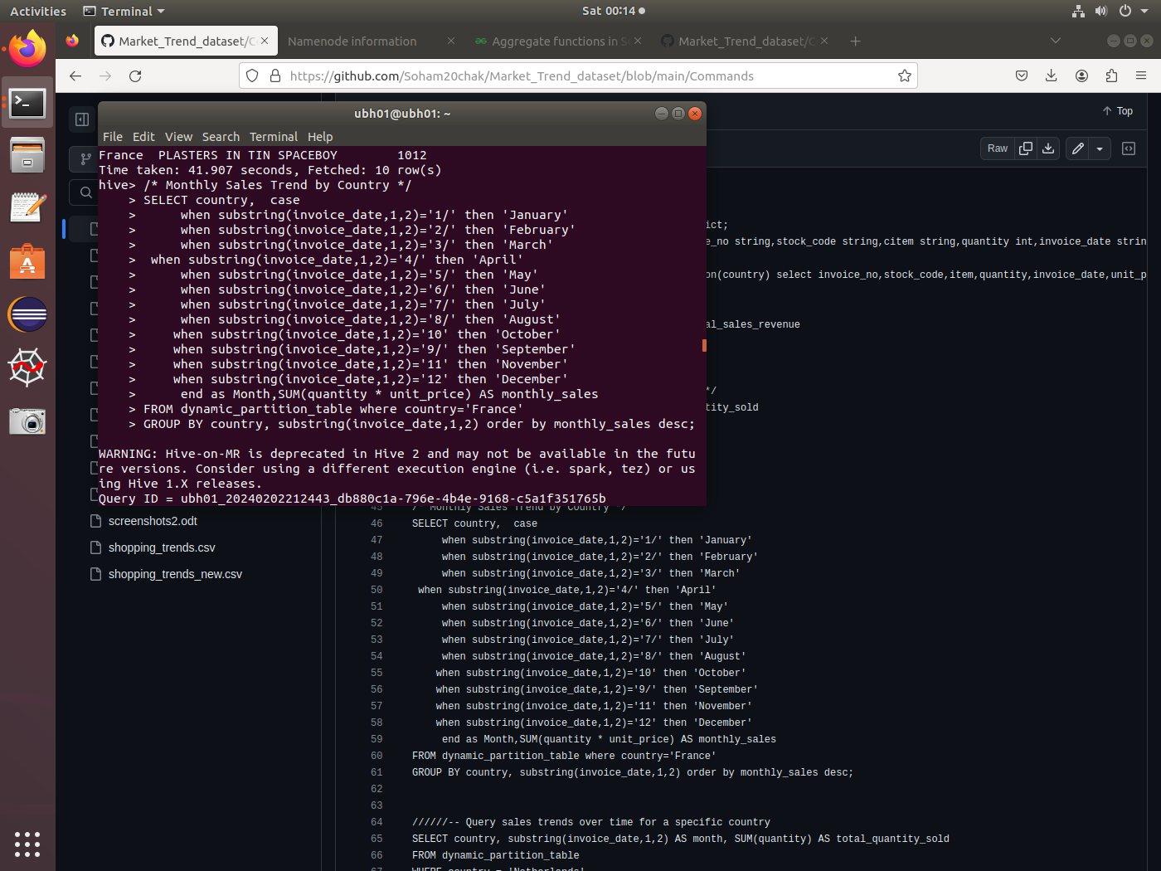

**Result:**

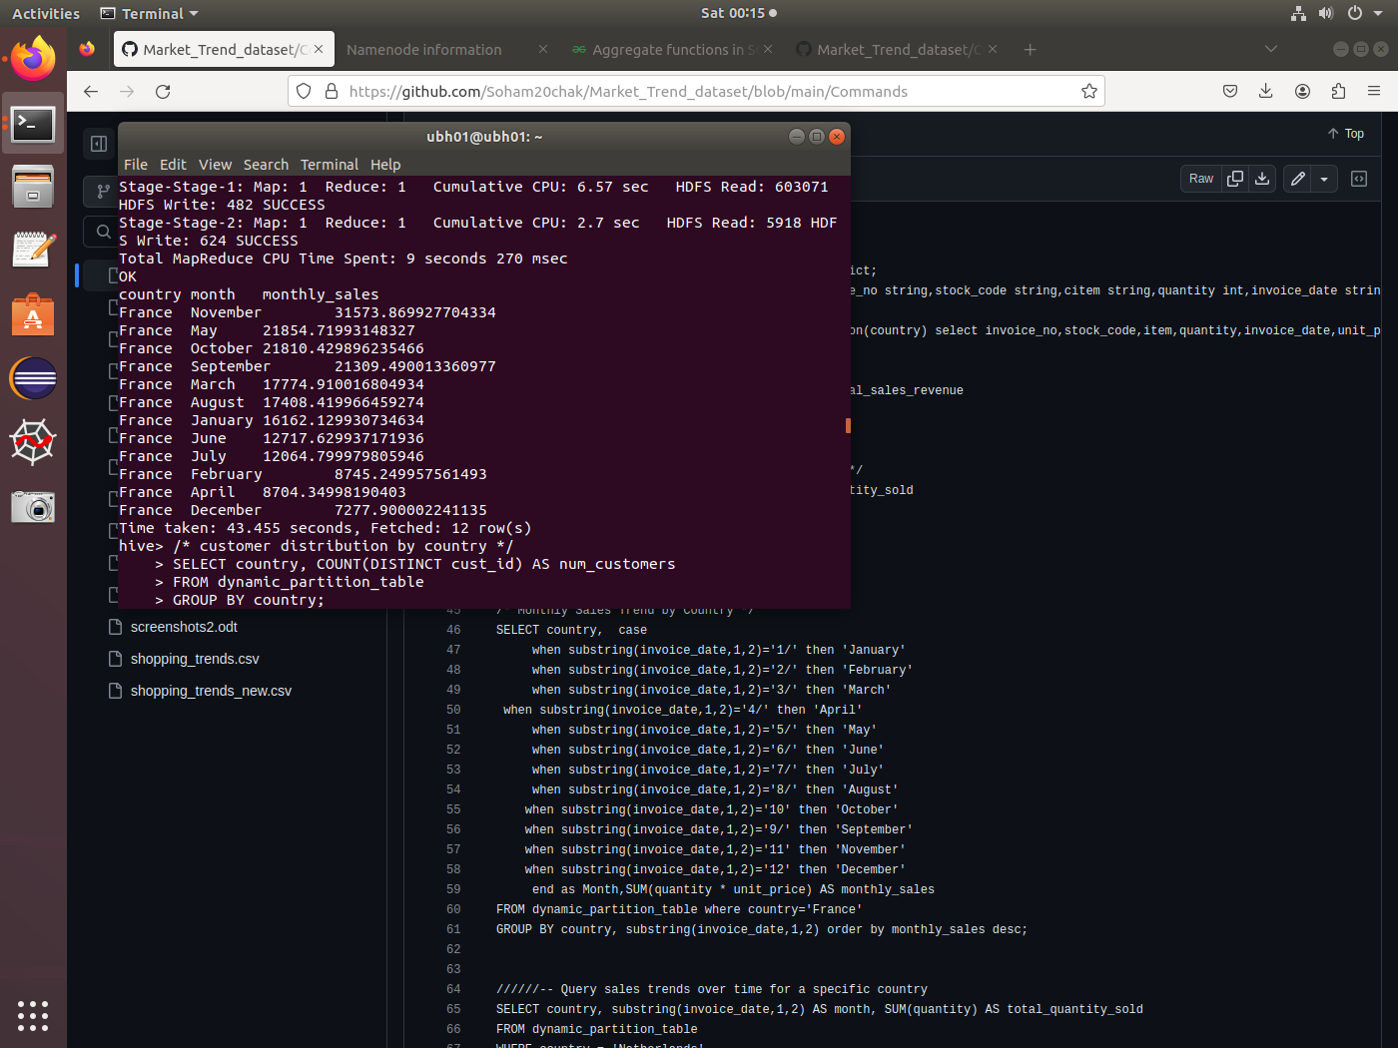

**4. Customer distribution by country:**

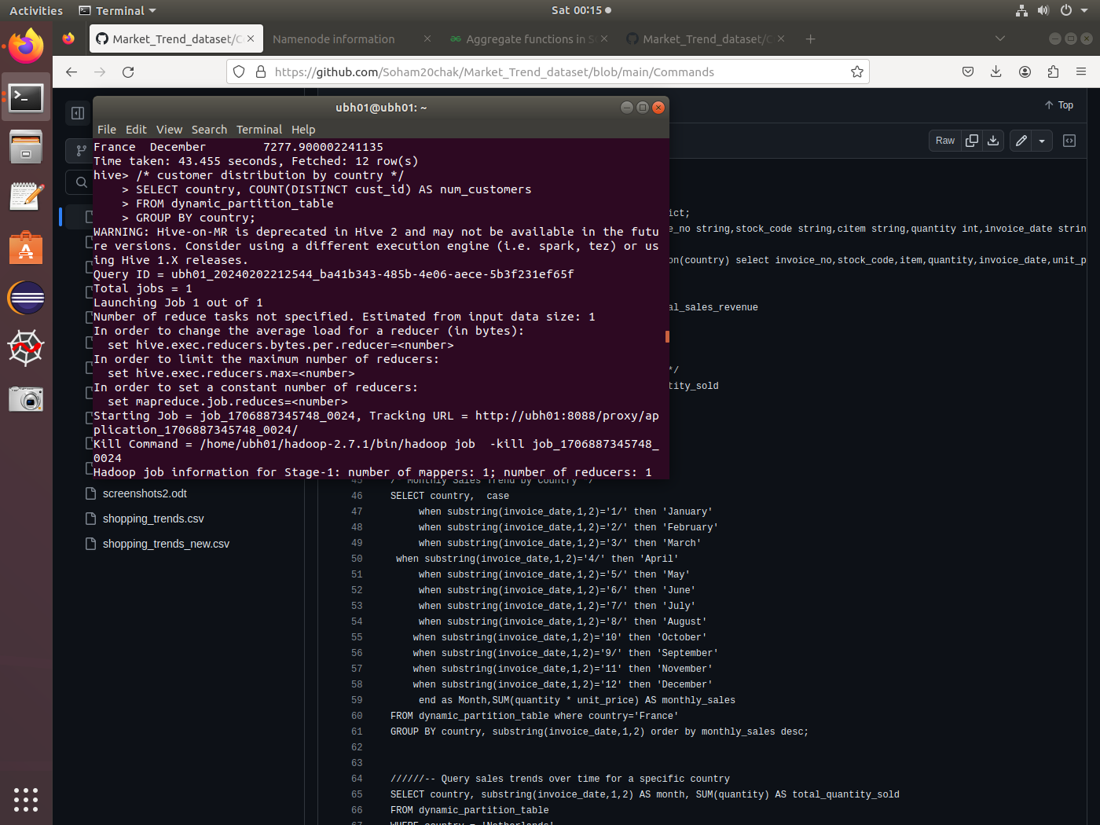

**Result:**

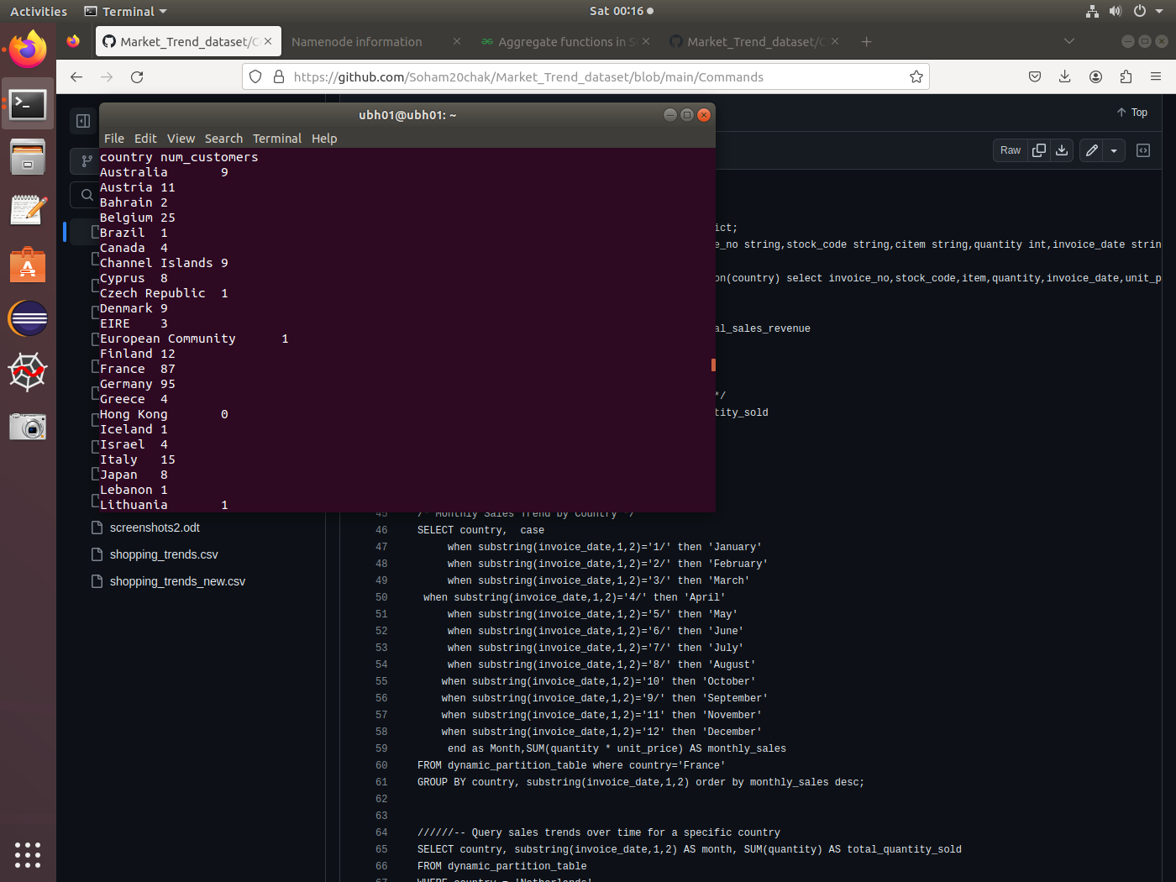

Like this , 38 rows for 38 countries will be displayed showing the number of distinct customers of each country .

**4.Bucketing :-**

Each bucket is a physical file stored on the filesystem and contains a subset of the data within the partition. Bucketing is particularly useful for improving query performance, especially when dealing with large datasets.

When creating a bucketed table in Hive, we specify the number of buckets to create. Hive then distributes the data within each partition evenly across the specified number of buckets. Each bucket is identified by a bucket number ranging from 0 to (num_buckets - 1).

Hive uses a deterministic bucketing algorithm to assign rows to buckets based on the values of one or more columns. This ensures that rows with the same values for the specified columns are always stored in the same bucket.

Creating a bucket table by using the column unit_price and taking the bucket number as 15

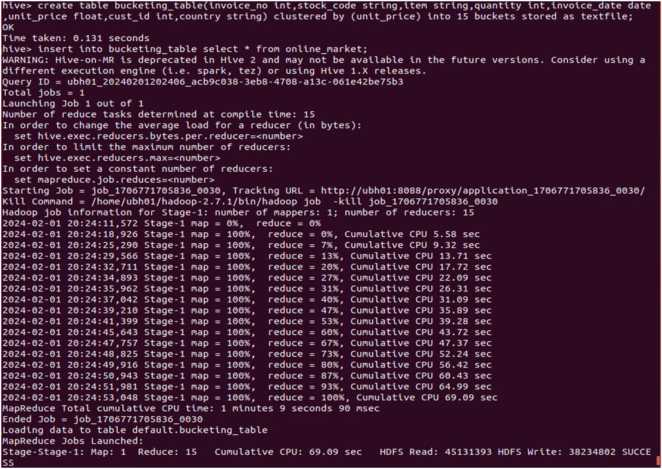

We can see that 15 buckets have been created

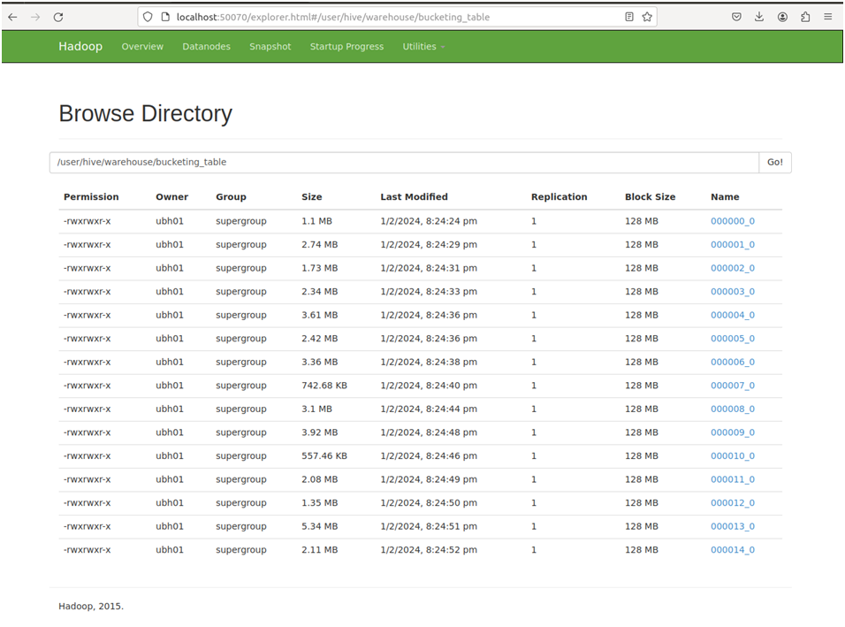

If we compare the time taken for the map reduce jobs then we will be able to see that the bucketed table behaves better than the normal table

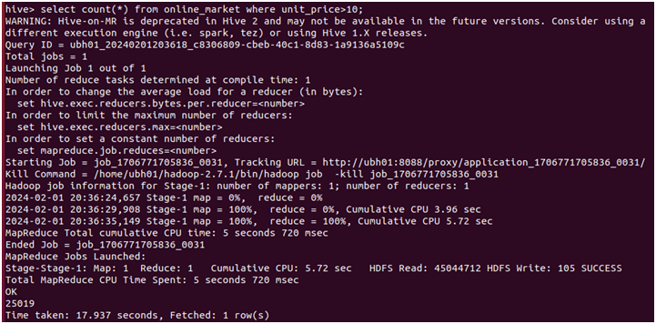

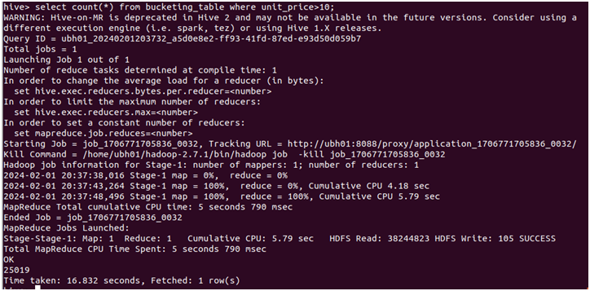

Bucketing in Hive can significantly improve aggregation performance by reducing data shuffling and minimizing the amount of data that needs to be processed during aggregation operations.

**Data Analysis using the Bucketed Table(by column unit_price) :**

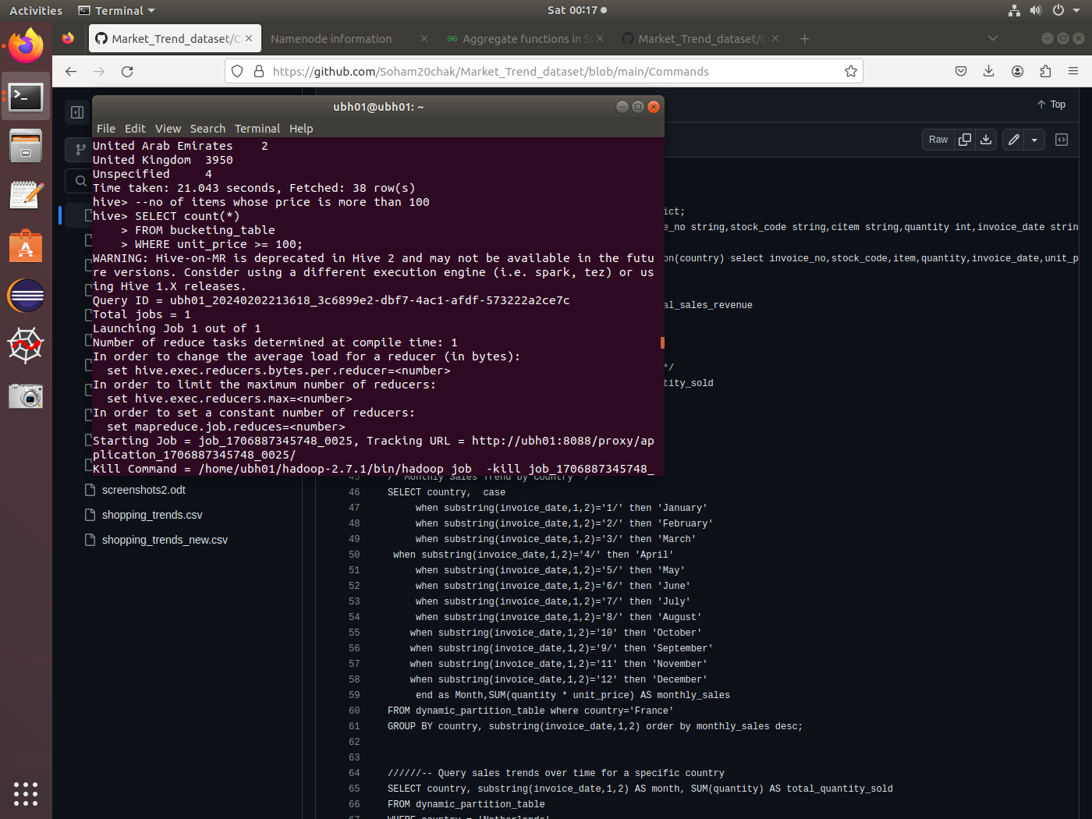

**Result:**

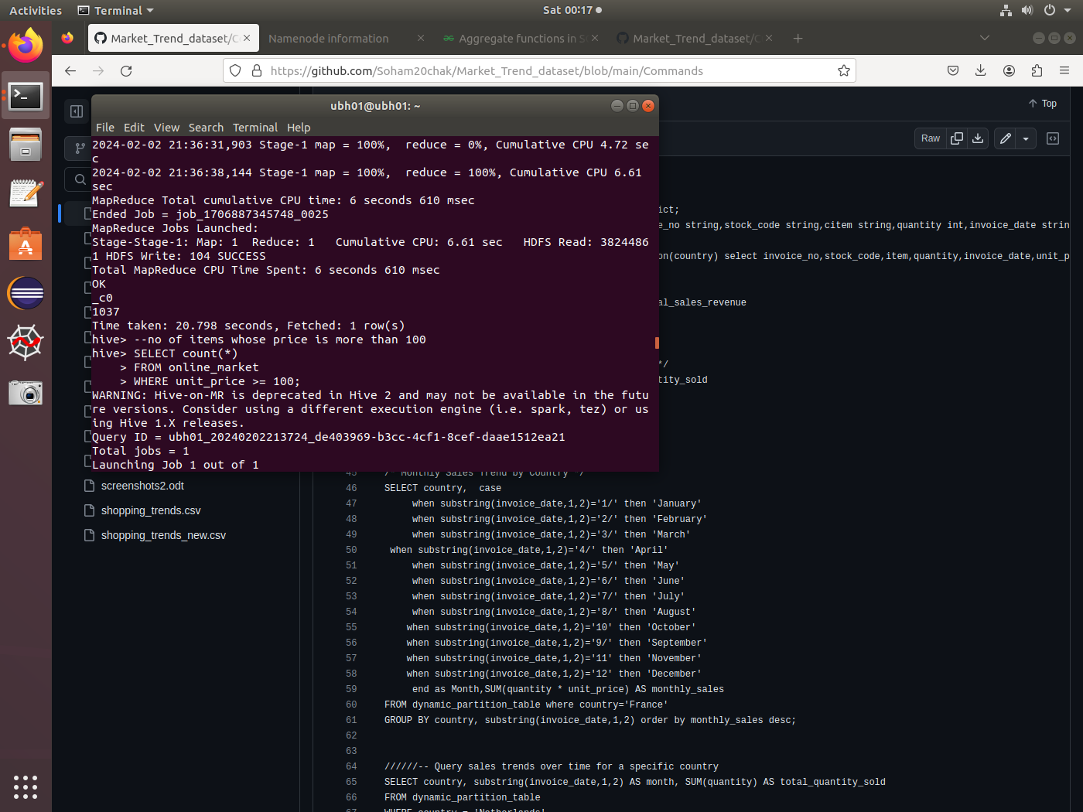

Now let us create another bucketed table called bucketing_table_by_customer using cust_id column and another table customer_info by using the column cust_id of Customers table .We have another table called the Customers table which has the column cust_id that we we will use to join with the cust_id of the online_market table to analyze the enhanced performance of joins using bucketing .

Bucketing in Hive can improve join performance by reducing data shuffling and minimizing the amount of data that needs to be processed during join operations.

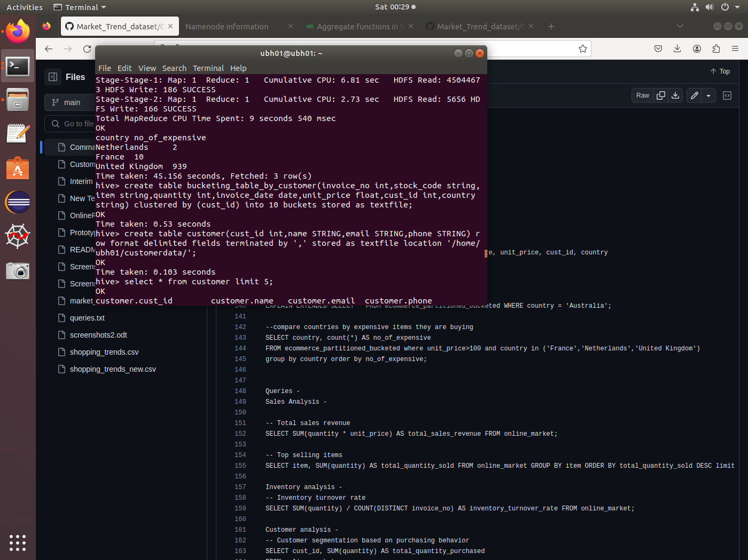

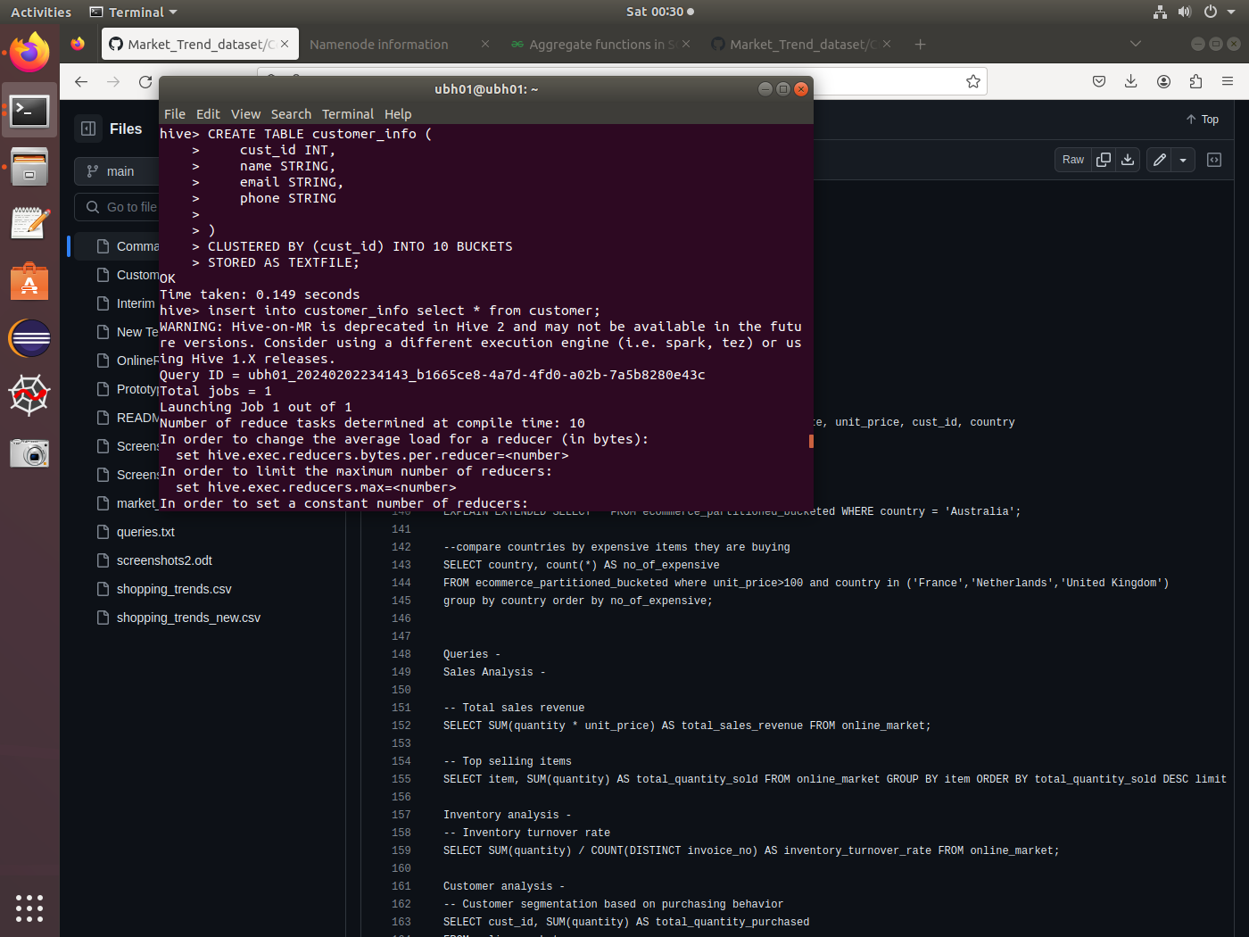

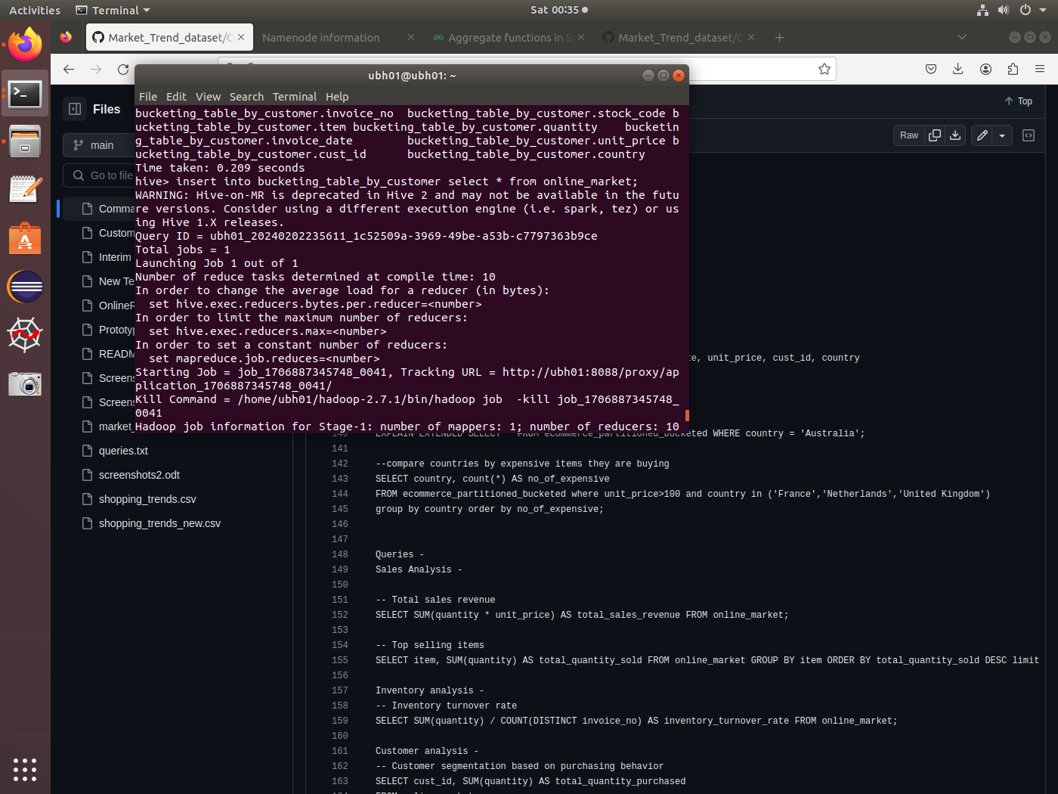

**Performing the join operation using Bucketing concept:**

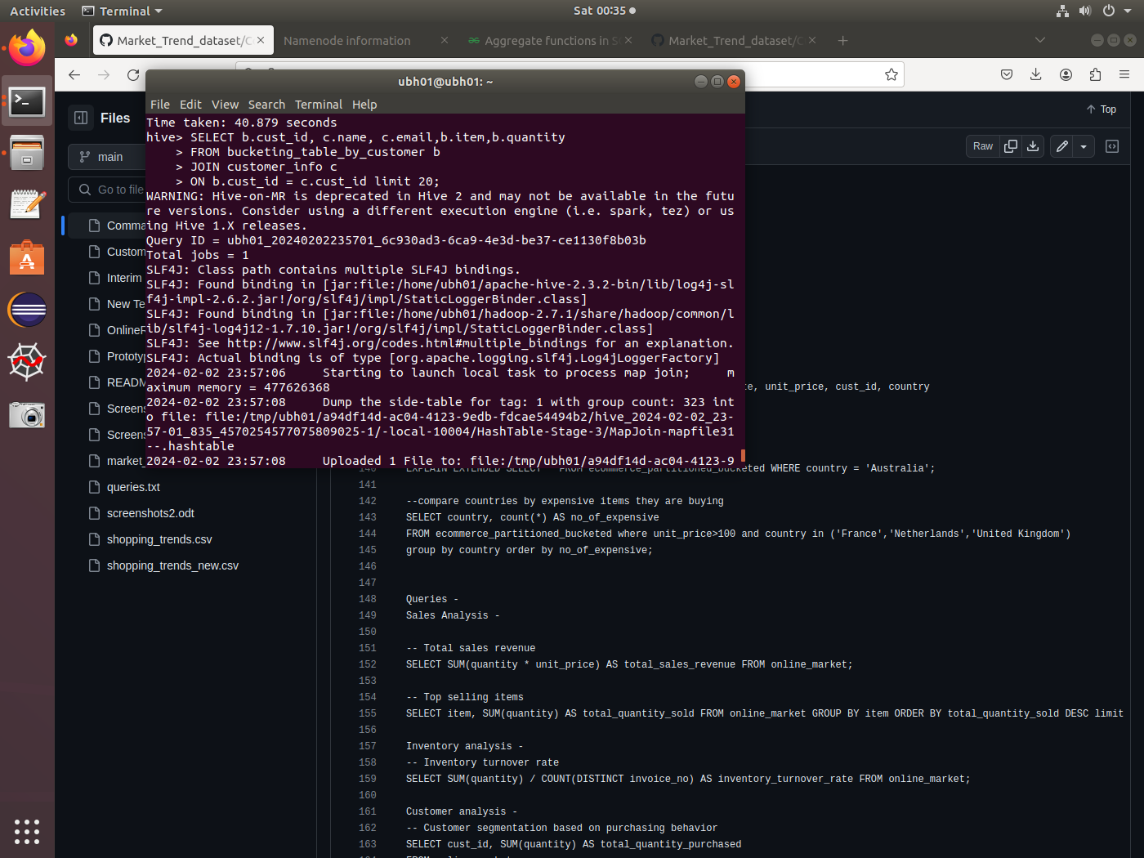

**Result:**

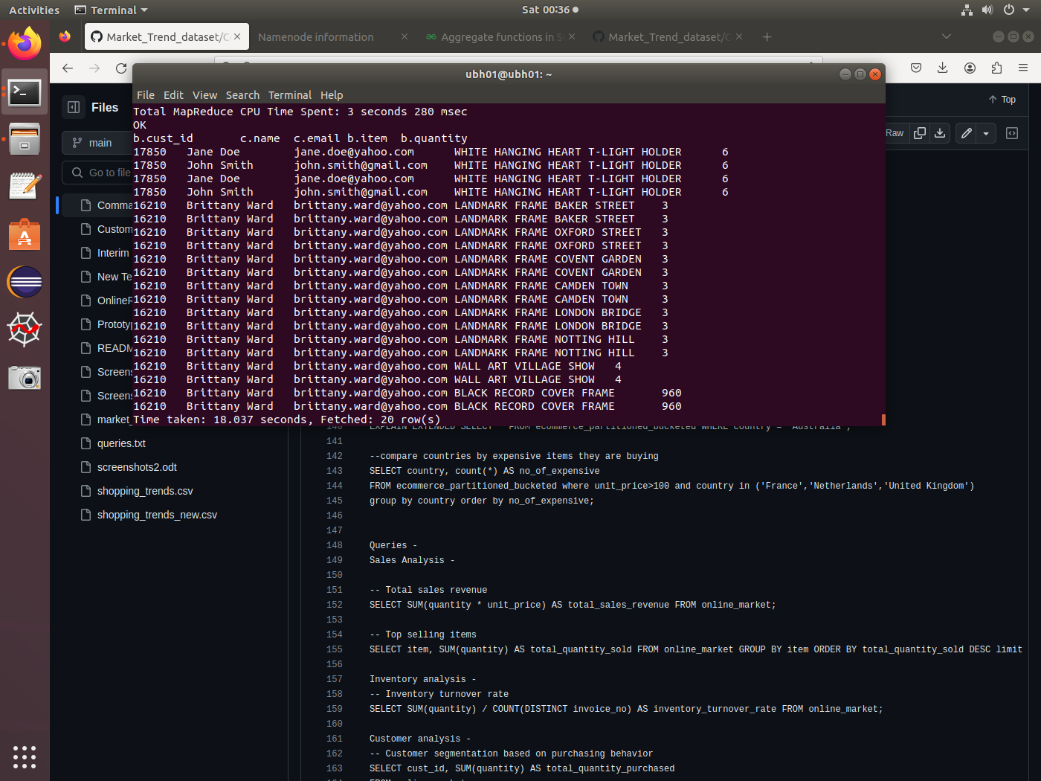

**5.Creating a partitioned and bucketed table :**

We combine the concepts of partitioning and bucketing to enhance the query performance

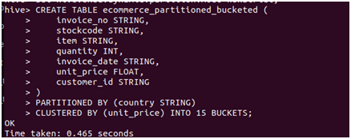

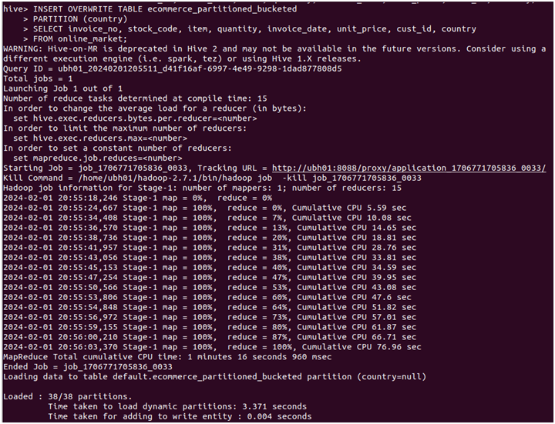

Overall, the combination of partitioning and bucketing in Hive offers powerful optimization capabilities for data retrieval and processing, particularly for queries involving joins and aggregations on large datasets. It helps reduce data scanning, minimize data shuffling, and enable efficient parallel processing, leading to improved query performance and faster execution times.

We can check how the partitions and buckets have been created in the hadoop file web server

The partitions appear as below

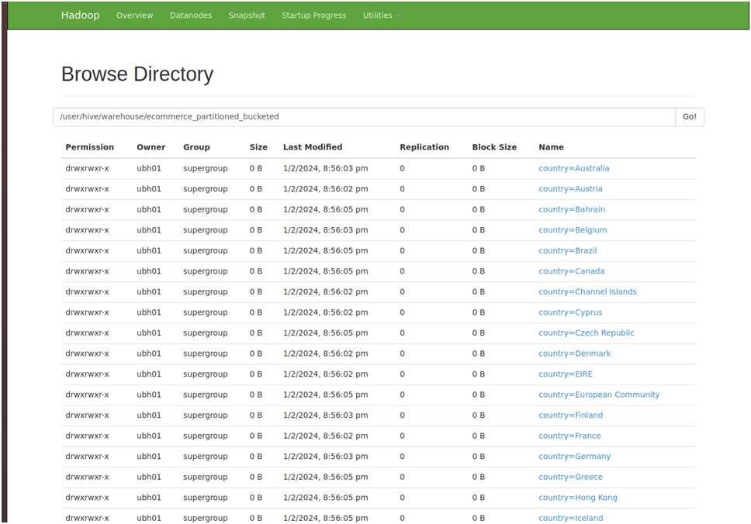

Inside each partition 15 buckets will be created

Partition pruning is performed first, skipping irrelevant partitions based on query predicates.

Within each selected partition, bucket pruning further reduces the amount of data to be processed, as only relevant buckets are scanned.

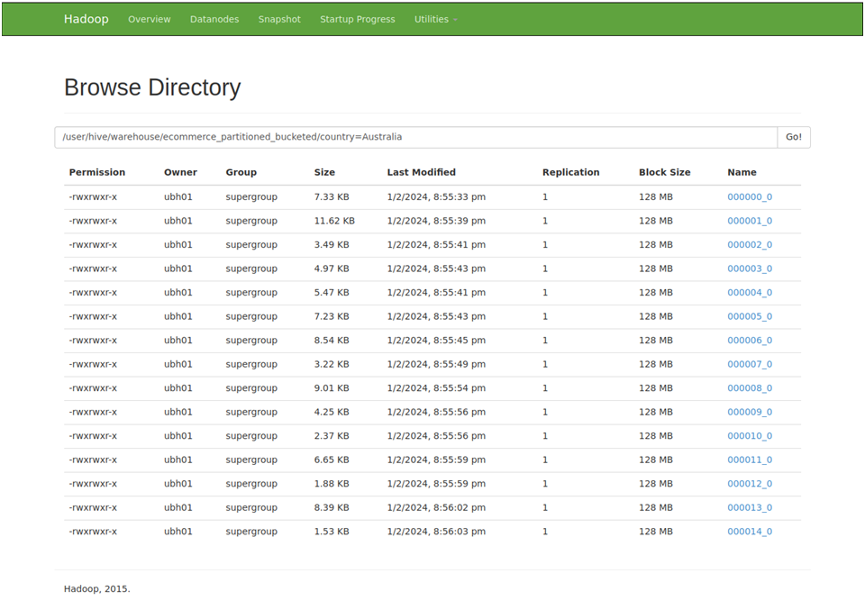

**Data Analysis using the Partitioned and Bucketed Table:**

**Compare countries by the expensive items they are buying:**

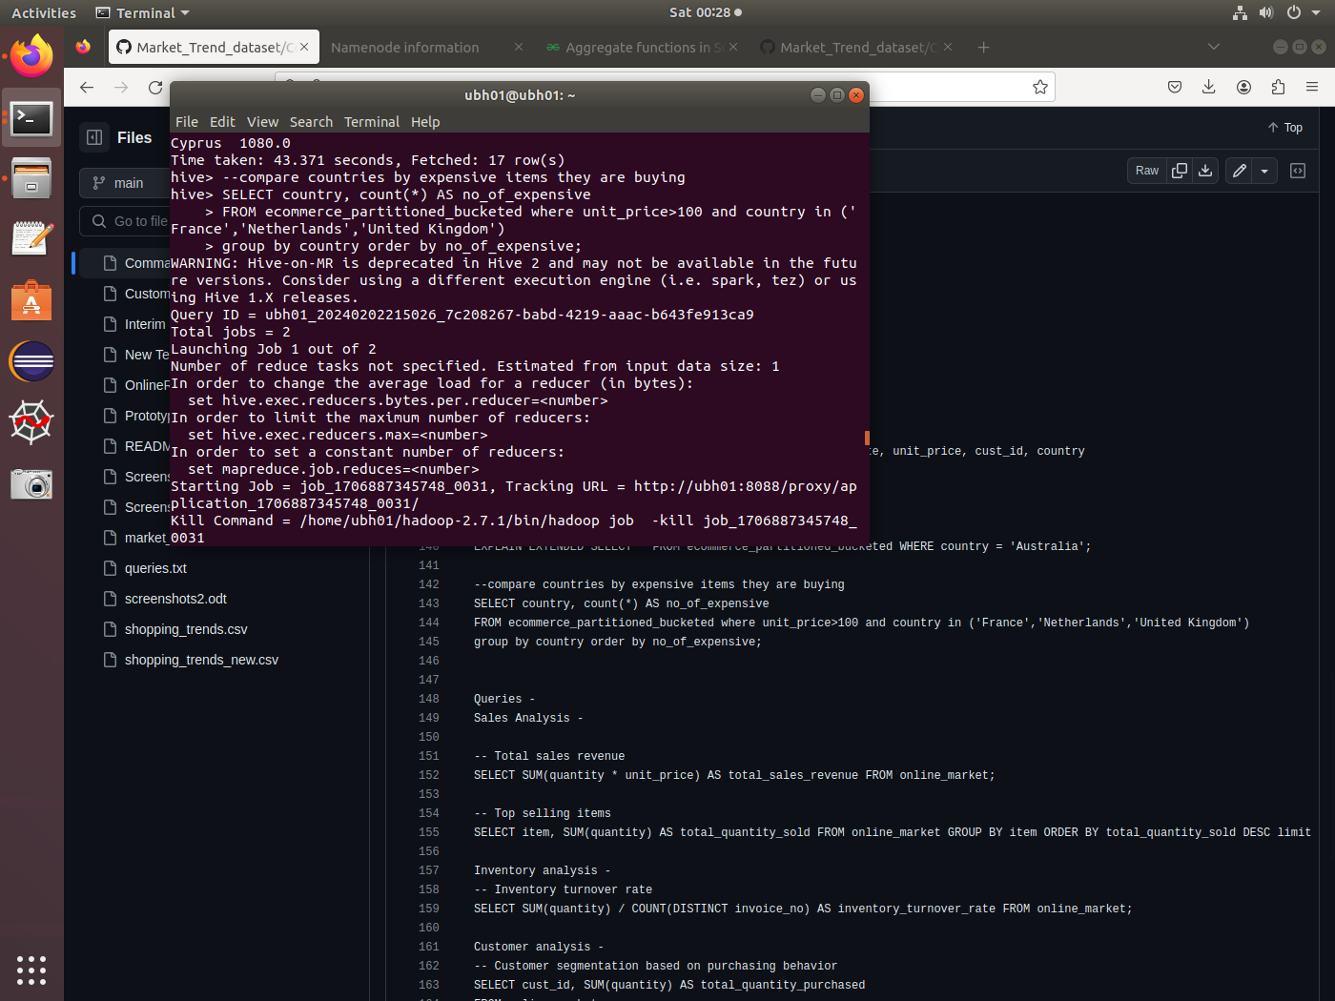

**Result:**

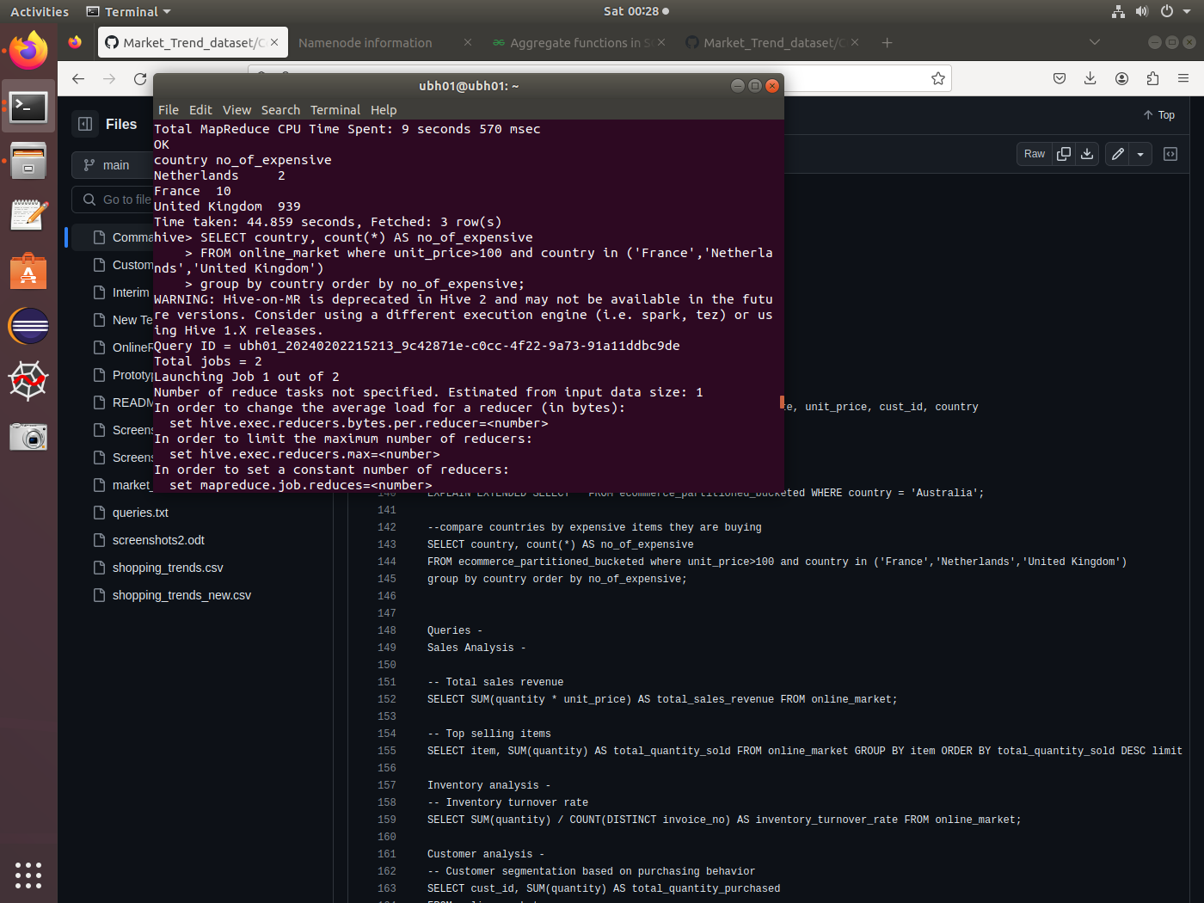

**Conclusion :-**

In conclusion, this project has demonstrated the significant performance improvements achievable in Hive by leveraging partitioning and bucketing techniques. By organizing data into partitions based on specific criteria and further dividing partitions into buckets, we have effectively reduced data scanning, enabled parallel processing, and optimized query execution.

Partitioning has streamlined data retrieval by allowing the query engine to skip irrelevant partitions, leading to faster query execution times. Additionally, partition pruning has further enhanced performance by eliminating unnecessary partitions based on query predicates.

Bucketing has complemented partitioning by organizing data within partitions into smaller, more manageable units. This has facilitated efficient data skipping, minimizing the number of data blocks that need to be read from disk during query execution.

Overall, the combined use of partitioning and bucketing in Hive has showcased substantial improvements in query performance, underscoring their effectiveness in optimizing data retrieval and processing. This project highlights the importance of strategic data organization techniques in maximizing the efficiency of Hive-based data analytics workflows.